I would like take the opportunity to introduce you to a range of library resources you can explore from home.
Our friendly FingerTip Team is available 9am to 5pm Monday to Friday, and 10am to 2pm on Saturday and Sunday to answer your library questions and help you to access our online resources. Call 03 941 7923 or live chat at Live Online.
How to access the Digital Library. You’ll need a library card and PIN number to access most of our eResources. No card? No problem, sign up online now.
If you need help, use our online chat service, LiveOnline, or talk to our friendly team by calling 03 941 7923.

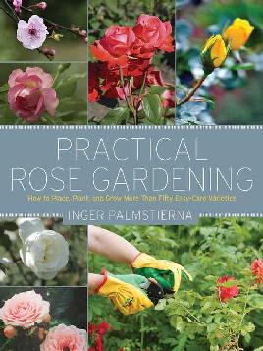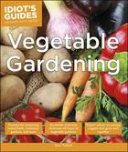

For the green thumbed take a look at our Gardening eBooks as well as downloadable audiobooks both of a whimsical and a serious nature.

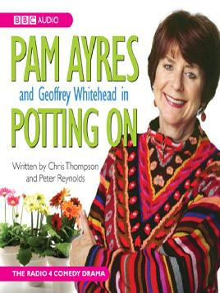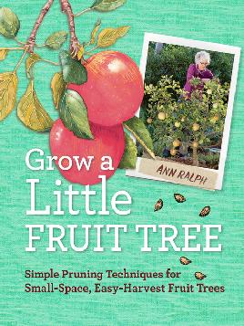

You can try your own search in the catalogue, for example search for keyword pruning and use the left hand filtering tick boxes to select eBooks, or view streaming videos from Kanopy.

Kanopy is our free streaming service, you can browse for documentaries under Science, Nature and Technology. Once there you can find films on Farming and food production and Environmental Science. Do a search for gardening and view all results, in next to no time you will be able to plan the garden of your dreams and know how to grow trees and shrubs.

You can even take a course on us, watch the Science of Gardening or Plant Science an Introduction to Botany from Kanopy

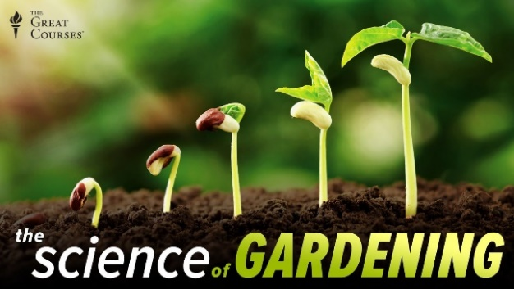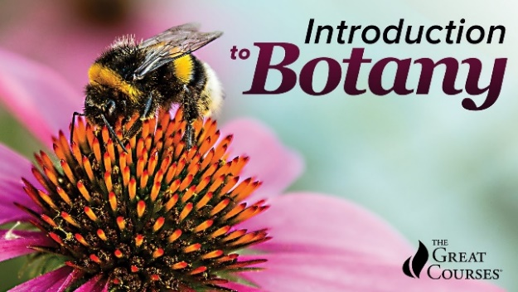

Missing your magazine fix then browse our Gardening eMagazines.

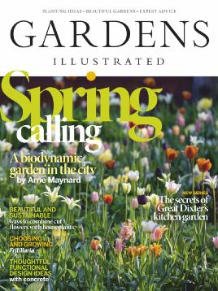

Dive into some research on that horticultural problem with Gale Onefile Gardening and Horticulture. This collection contains articles about gardening, landscaping, and horticulture. The collection includes full-text and peer-reviewed journals.
GreenFILE examines the environmental effects of individuals, corporations and local/national governments, and what can be done to minimise these effects.
Topics covered include; sustainable agriculture, climate change, recycling, pollution renewable energy, green building.

There’s so much to look at you might want to contact us for a live chat at Live Online.
Ngā Mihi
Fay
General Reference Librarian
Tuhuratanga | Discovery, Level 3, Tūranga
Christchurch City Libraries
TEL: 03 941 7923

